FMLM Trainee Steering Group
Regional Lead Recruitment Pack

CONTENTS

Advertisement 3
Application Form 5
Interview Structure 7
Terms of Reference for FMLM TSG 8
Personal and Role Specification for FMLM TSG Regional Lead 13
Statement of Inclusivity 15

ADVERTISEMENT

The Faculty of Medical Leadership and Management (FMLM) is offering the opportunity for several trainee members to join the Trainee Steering Group (TSG). The TSG is a representative group ensuring the views and interests of trainee members are represented to the FMLM. The purpose of the TSG is to promote the values of the FMLM to trainees and to provide strategic direction for medical leadership and management for its trainee members.

The FMLM is currently inviting its trainee members to apply for the position of Regional Lead for the areas below, with successful applicants representing their respective Region on the TSG:
- East of England
- London
- North-Central (Yorkshire and Humber Deanery)
- North-East (North-East and North Cumbria Deanery)
- North-West (North-West Deanery)
- Northern Ireland
- South-East (Kent, Surrey & Sussex Deanery)
- South-West (Peninsula & Severn Deaneries)
- North/West Wales (Co-Lead Position with Lead for South/East Wales)

As a Regional Lead you will be encouraged and supported to develop innovative projects within your Region, collaborate with neighbouring Regions, and contribute to the overall direction of the TSG, ultimately representing trainees on behalf of the FMLM. You will be expected to engage with and expand the network of trainees based in your allocated region, promoting medical leadership and management, whilst seeking opportunities to liaise with local and national external organisations to support leadership activities and initiatives.

In addition, there is an opportunity for significant professional and personal development via access to FMLM training opportunities, mentorship, and experiential learning through leading and delivering projects. The FMLM is committed to developing leadership and management among trainees. Joining the TSG will give you the chance to have your say on how this is achieved and delivered.

Eligibility: Trainees based in the advertised deaneries, with FMLM membership at the time of application.

To Apply: Applications are made by returning the application form below to tsg@fmlm.ac.uk by Monday 3rd April 2023.

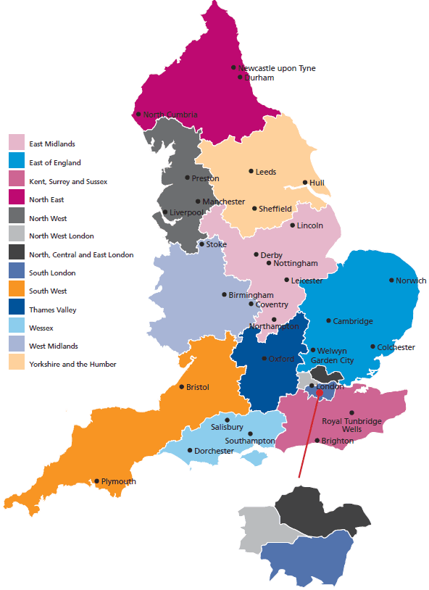

APPLICATION FORM
Personal Details

Full name

FMLM number

Position applied for

Year of primary medical
qualification
Grade and speciality

Hospital and deanery

Expected CCT date

Email

Telephone number

Please answer the following questions:

Why are you interested in this role? (200 words)

What previous experience makes you suited to the role? (200 words)

Tell us about a time where you have led change or service development: (200 words)

Referee

Please provide the details of a referee; the referee may be contacted to aid decision making or to confirm details supplied in this application.

Applications are made by returning the application form to tsg@fmlm.ac.uk.

Thank you for taking the time to complete this application.

INTERVIEW STRUCTURE

Successful applicants will be invited to participate in a short informal interview one evening between 8pm and 9.30pm between the 10th April and 5th May. If these times are unsuitable, we will do our best to accommodate you. The interview will be conducted by two to three existing TSG members and will last around 20 minutes. The interview also offers you an opportunity to discuss any questions you may have regarding the FMLM and the TSG.

The interview follows a value-based recruitment model, with questions focussed on the themes outlined in the table below.

QUESTION THEMES
Commitment to medical leadership & management & its role in healthcare.
Knowledge & understanding of the FMLM, the TSG & its activities.
Organisation, self-motivation & innovation.
Inclusive, reflective & accountable team-member.

TERMS OF REFERENCE
FMLM Trainee Steering Group
- Purpose

The TSG is a representative group ensuring the views and interests of trainee members are represented to FMLM. Its purpose is to promote FMLM’s values to trainee members and to provide a strategic direction for medical leadership and management for its trainee members.

- Composition of the committee

The composition of the committee represents the diversity of its membership:

ROLE | TERM | APPOINTMENT
Chair | Two years  (plus six-month handover period if required) | Internal application, appointed by ballot, TSG members as voting members
Vice-chair | Two years | Internal application, appointed by ballot, TSG members as voting members
General Secretary | Two years  (plus a six-month handover period if required) | Internal application, appointed by ballot, TSG members as voting members
Social Media Lead (in addition to Regional Lead role) | Two years | Self-nomination, internal vote
Inclusion Lead (in addition to Regional Lead role) | Two years | Self-nomination, internal vote
International Medical Graduate Lead | Two years | Competitive external application (current TSG members also eligible to apply through this process)  Application process coordinated by the General Secretary. Shortlisting and interviewing will be conducted by at least two members of the TSG (one of which to be Chair or Vice-Chair, except if there is a conflict of interest)
Research Lead | Two years | Competitive external application (current TSG members also eligible to apply through this process; see regional lead for details)
Regional Lead(s) to include:  - Armed Forces  - Scotland  - Wales  - Northern Ireland  - North of England  - Midlands  - East of England  - South of England  - London  Due to the varying size of Regions, some Regions may be subdivided to enable improved representation.  Scotland and Wales will have two Regional Co-Leads. | Three years | Competitive external application (current TSG members also eligible to apply through this process)  Application process coordinated by the General Secretary. Shortlisting and interviewing will be conducted by at least two members of the TSG (one of which to be Chair or Vice-Chair, where possible)
Deputy Regional Leads  (As applicable) | Three years | Deputy Regional leads may be appointed to a Region by the TSG Chair as the next appointable candidates following a Regional Lead competitive application process
Foundation Lead | Two years if recruited as a Foundation Year 1 doctor  18 months if recruited as a Foundation Year 2 doctor | Competitive external application (current eligible TSG members also eligible to apply through this process)  Application process coordinated by the General Secretary. Shortlisting and interviewing will be conducted by at least two members of the TSG (one of which to be Chair or Vice-Chair, except if there is a conflict of interest)
FMLM’s National Medical Director’s Clinical Fellow | 1 year | Appointed by FMLM

Meetings

Meetings will be chaired by the Chair and in their absence the Vice-chair. Decisions will be made on consensus where warranted. Voting rights are available to all members of the TSG, except for the FMLM fellow.

Prior to meetings, Leads and Regional Representatives are expected to submit progress reports, unless advised otherwise by the Chair. The committee will meet virtually at least three times a year and will meet twice in person where possible. Inability to attend meetings due to other commitments, both professional and personal, is anticipated, along with exceptional circumstances. In such circumstances, members are requested to send their apologies to one of TSG Executive with as much notice as possible.

Minutes

Minutes and actions of each meeting will be recorded and circulated; this will be the responsibility of the General Secretary. It is the responsibility of each TSG member to review the minutes and complete actions required.

- Remit

To fulfil the aims of TSG, the activities of the committee include, but are not limited to mentoring, coaching, conferences, seminars, events, policy, publications, representation, social media, webinars, and leadership development. Through these activities, TSG members will:
- Promote and signpost FMLM services and benefits that support trainee development.
- Support emerging trainee medical leaders.
- Align with FMLM and support local/regional/national evidence-based initiatives to promote good practice.
- Strengthen and promote inclusivity at all levels by:
- Helping members to recognise their leadership capabilities.
- Supporting applications for FMLM Associate Fellowship.
- Promoting trainees networking at the FMLM International Healthcare Leadership Conference.
- Signposting trainees to national, regional, and local events that support best practice in medical leadership and management.
- Remuneration

All roles as part of the FMLM TSG are voluntary and non-remunerated. Individuals are eligible to claim expenses for travel and subsistence costs necessarily incurred in line with the relevant FMLM policies.

- Time commitment

The TSG members are expected to actively engage with the work of the committee and must ensure they are able to devote enough time to ensure satisfactory discharge their duties. Members are strongly encouraged to liaise with the TSG Executive if there are professional or personal commitments or challenges which may affect their ability to contribute to the TSG. In such an event, the Executive will consider the individual circumstance and how best to support the member.

- Accountability framework

TSG members (and their associated activities) are accountable to the TSG Chair, who in turn reports to FMLM’s Council. Annually, the TSG are asked to submit their proposed plans to the CEO for initial sign off. These plans are then passed to Council for final sign off. This forms a mandate between Council and the TSG. The TSG can continue with activities during this process.

TSG will be asked to report their progress against their mandate at suitable intervals.

Formal publications follow FMLM’s internal procedure for ratification.

- Role specification

If deemed necessary, amendments, modifications and variations of the role specification can be instigated through discussion and agreement between the relevant parties.

- FMLM support

On appointment to the role, the FMLM will provide a copy of the terms of reference and an appointment letter. An annual summary letter will be provided for evidence of the role and achievements, which can be displayed in the portfolio, in addition to an end of role letter.

TSG REGIONAL LEAD PERSONAL AND ROLE SPECIFICATION

PERSONAL SPECIFICATION FOR ALL TSG ROLES
 | Essential | Desirable
Academic &  Professional | - Doctor in training within the UK  - Member of FMLM | - Extra-curricular qualification in management/clinical leadership  - Opportunities sought for experience in management/clinical leadership
Knowledge | - Good understanding of the aims and aspirations of the TSG and FMLM | - Attendance at FMLM/TSG events or relevant leadership and management events
Interests | - Demonstrates ongoing interest in leadership and management | - A track record of consistent involvement in management and leadership projects
Skills | - Ability work in a transparent, efficient, and accountable manner as a team player  - Experience of actively participating in events, committees, activities, or projects | - Experience of managing/leading teams at a local/regional/national level
Personal | - Excellent oral and written communication skills  - Evidence of being reliable, organised, and self-motivated  - Fosters a culture of continuous improvement  - Open to the perspectives of others and works well in a team  - Responsive and proactive  - Able to commit sufficient time to discharge the duties of the role | - Ability to think creatively and innovatively  - To generate and positively contribute ideas, suggestions, and feedback
ROLE SPECIFICATION FOR REGIONAL & DEPUTY REGIONAL LEADS
Remit | Accountable to the Vice-chair, Regional Leads are responsible for:  - Representing the FMLM trainee members within their region.  - Regular engagement with TSG via conference calls and face to face meetings with the submission of progress updates prior to TSG meetings.  - Contributing to TSG workstreams to deliver the TSG strategy.  - Supporting the growth of the FMLM trainee member base within their region.  - Liaising with their FMLM region and Medical School Group (MSG) counterparts to achieve strong regional networks of engagement with FMLM goals.  - Where applicable leads a regional trainee sub-committee to support FMLM region activities and TSG workstreams.  - Delivering at least one event per year for trainees within your region (e.g. seminars, webinars, lectures, workshops etc.) and a further contribution to either a further regional event, collaboration with another region or a national event.  - Promoting FMLM’s values and vision to trainees within your region.  Accountable to the Vice-chair and their Regional Leads, Deputy Regional Leads can deputise for Regional Leads at TSG meetings. In addition, they will assist Regional Leads, where required, in all the above responsibilities. Deputy Regional Leads can additionally contribute to TSG workstreams.
Eligibility | Essential  - Ability to work well and communicate with others at all levels.  - A track record of participation in project work, with emphasis on management and leadership remit.  Desirable  Experience of other leadership or representative roles in a regional or national setting.

STATEMENT OF INCLUSIVITY

The TSG strives to ensure that equality, diversity, and inclusivity is embedded in all that we do, firmly believing that our collaborative efforts and activities are stronger and more innovative the more diverse and inclusive we are as a committee. It also ensures that we better reflect the views and needs of aspiring trainee leaders, as well as the patients we serve in our clinical roles.

To the TSG, diversity and inclusion is an essential aspect of our work. We are committed to progressing our vision through our TSG Equality, Diversity, and Inclusivity Strategy, and via the introduction of a values-based approach to recruitment. We also promote inclusive leadership through our various activities, for example, the TSG Leadership Commitment promotes access to leadership opportunities which incur no personal financial commitment or investment of non-working time, for all trainees. We also ran the first of our Inclusive Leadership Webinar in Winter 2021 with extremely positive feedback and have since appointed a dedicated Inclusivity Lead.

However, the TSG acknowledges that inclusivity and equity of opportunity can be highly individualised and personal in nature, so, how does this relate to the TSG recruitment process?

We are currently working towards providing alternative means to submit applications, and ways to minimise potential unconscious bias, such as unconscious bias training for members of the TSG.

After receiving your application, it will be blinded prior to being reviewed. We aim to interview as many applicants as we can and provide interview question themes in advance to assist with preparation. To aid recruitment planning we provisionally schedule interview dates in advance, but if these do not suit, we will try to re-organise to a more convenient date and time for candidates where possible.

For our current round of recruitment, we are also trialling means to enable applicants with protected characteristics to support diversity and inclusion. If you identify as having a protected characteristic, please feel able to approach the TSG for a discussion about the recruitment process prior to the application deadline or interview.

During the interview you may request a break (at any point) and for any question to be repeated, or the meaning of words or phrases clarified. If you require further adjustments to the interview process, please inform us in advance and we will do our best to accommodate you. Any personal information discussed as part of the application or interview process will be kept confidential.

Everyone is welcome on the TSG. We look forward to receiving your applications and invite any feedback on how we can improve our recruitment and interview process further.

